

**Design Studio #4 - Weekly Progress Report #13**

DS Instructor: Gülbin DURAL

Partners:

* Fatih ÇALIŞ
* Fatih ÇAM
* Recep GÜNAY
* Huzeyfe HİNTOĞLU
* Sarah ILYAS

This week, we have tested the rotation part of the shooting mechanism in different conditions. We have tried to solve the problems we have faced with this mechanism. In the end, we could not solve it in practice. First, we tried the system with the previous design of the spiral and we saw that the mechanism was not working since the rod rolls out of the spiral while the spring is compressed. In order to solve this, we designed a new spiral with a path for the rod to rotate inside so that it will not roll out. The new design is shown in Figure 1.

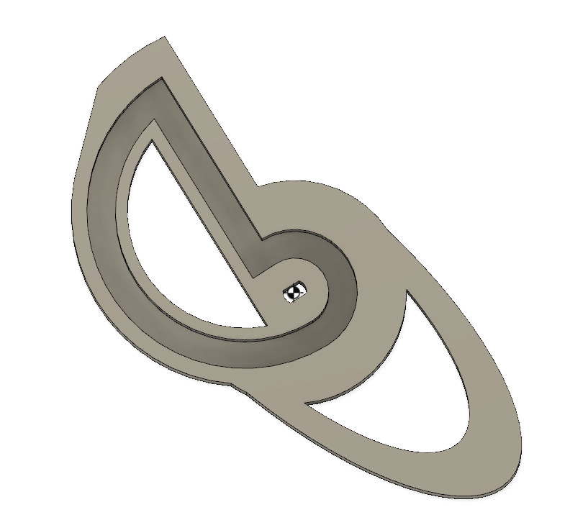

Figure 1: The new design of the spiral to compress the spring in the shooting mechanism

The problem with this design is that when we put a thin stick in the path, it does not stop the rod to roll out and when we put a thicker one, the spiral stops rotating at some point due to friction force. We tried to use a thin stick and glued a ring around it for the same purpose and the result was the same. Therefore, we have proposed a few solution methods for the shooting mechanism and we will test them in the following weeks. The first one is using a square rod so that the rod will not roll out of the spiral while the spring is being compressed. For this one, we need to find a square rod with rail mechanism that slides really well inside the rail. We have bought one and it does not slide well. We are planning to put some machine oil inside it or buy a used one that will slide more easily. The second solution method is to put a wheel around the stick that goes inside the spiral so that when the spiral is rotating, it will rotate the wheel and it will stop the rod from rolling out. For this, we need a wheel small enough to go inside the spiral path, fit around the stick and move freely. Another method is to put obstructions around the stick hanging from the upper floor so that it will stop the rod from rolling out. This solution has the risk of stopping the motor to move too. Another method is to use a stronger stepper motor and try the previous methods that have failed. Another method is to integrate a gear mechaism with the stepper motor to increase the torque and use a different linear actuator based on gears. The rod will have linear gears on it and the gear that will actuate it will have quarter of its teeth removed to allow for the shooting action. This gear might be connected to a several intermediate gears according to the torque requirement and finally to a gear that is connected to the shaft of the stepper motor. The upper linear actuator gear mechnism will be as shown in Figure 2 but quarter of the teeth removed from the round gear.

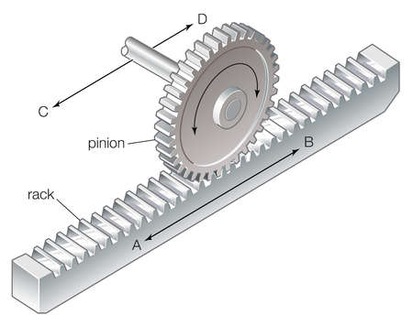

Figure 2: The linear actuator mechanism

The final look of the linear actuator mechnasim will as shown in Figure 3. We will try all these solution methods and choose the best one in terms of power consumption, shooting force, stability, response time and cost.(Recep Günay)

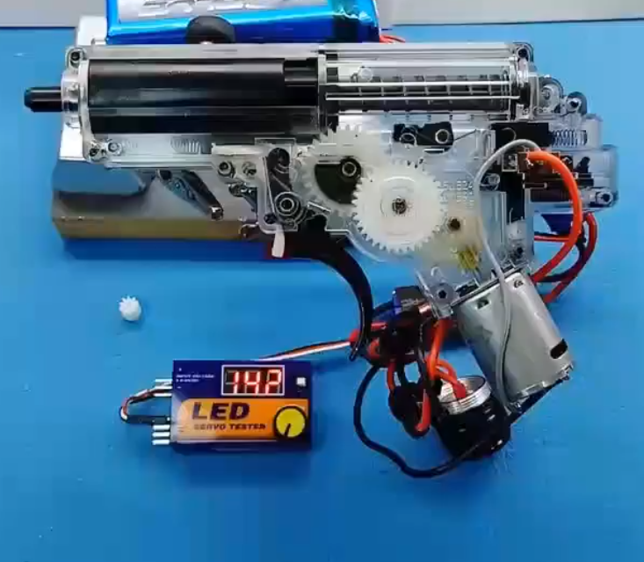

Figure 3: The linear actuator system described in the final solution proposal